Financial Lit Name: _______________________

______________ _____________

WS Assessment

Target 18:

Cash flow and Budgeting

**I can:**

* Create and use a budget check-off matrix.
* Visualize and interpret a budget using a pie chart,

a bar graph, a line graph, and a budget line graph

* Develop and interpret a cash flow chart.
* Develop and interpret a frequency budget plan.
* Develop and interpret a yearlong expense

budget plan.

**Unit 8 Math Topics:**

* Circle (sectors, central angel) Cusp Domain
* Fractions, decimals, and ratios Greatest integer function
* Linear equations and inequalities Literal expressions
* Matrices Piecewise functions Proportions
* Rational and exponential equations
* Read and interpret data: line graphs, bar graphs, circle graphs
* Slope and graphing linear functions
* Spreadsheets and formulas
* Systems of equations Volume

Charting a Budget

Charts that relate to your personal budget can help you understand how and when money is coming in and going out. Perhaps the most common budget chart is the **budget matrix**.

A spreadsheet is an **electronic matrix**.

A budget matrix can contain numeric entries or information on when certain account deposits and withdrawals are made over a period of time.

Budget matrices are not the only ways to visualize financial obligations over time. Other forms of graphical displays are as follows:

• **Pie Chart** A pie chart is a graphic display in the form of a circle divided into pie-shaped segments. A pie chart (or circle graph) is used to present data in percentages.

• **Line Graph** A line graph is used to depict changes over time on a coordinate grid.

• **Bar Graph** A bar graph uses rectangular bars to compare categories of data.

• **Budget Line Graph** This type of graph is used when a consumer is comparing two categories of expenses. It indicates the amount that can be allotted to each expense so that both categories can be afforded within a certain income.

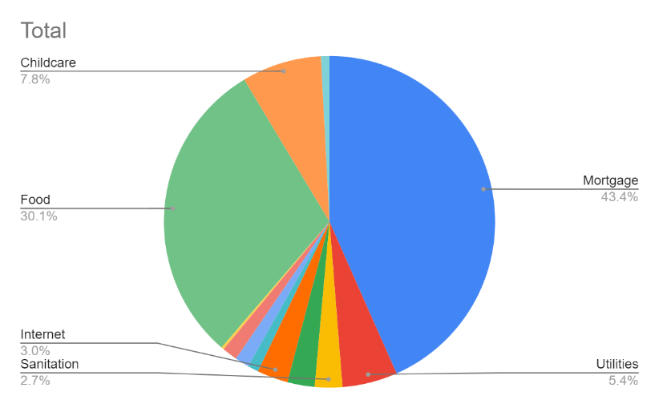Create a year-long **budget check-off matrix** that keeps track of the following household expenses and when they are due. Stamp

Mortgage: $1729.25 monthly

Utilities: $215 monthly

Sanitation: $320 quarterly

Insurance: $635 semiannually

Internet: $725 semiannually

Land Line Telephone: $42 monthly

Cellular Telephone: $55 monthly Lawn and Garden: $120 monthly, April–September only

Snow Removal: $40 November, January, March only Food: $1200 monthly

Childcare: $620 every other month beginning with February

Vet Expenses: $200 semiannually

Then create a pie chart for stamp. What info can you get from this pie chart?

Re-create this pie chart for stamp, then calculate the angle degree for each pie.





Kate and Paul budget $800 per month for transportation as shown in the pie chart.

Calculate the amount they spend for each category?

Back to the **budget matrix** above, create this bar graph for stamp

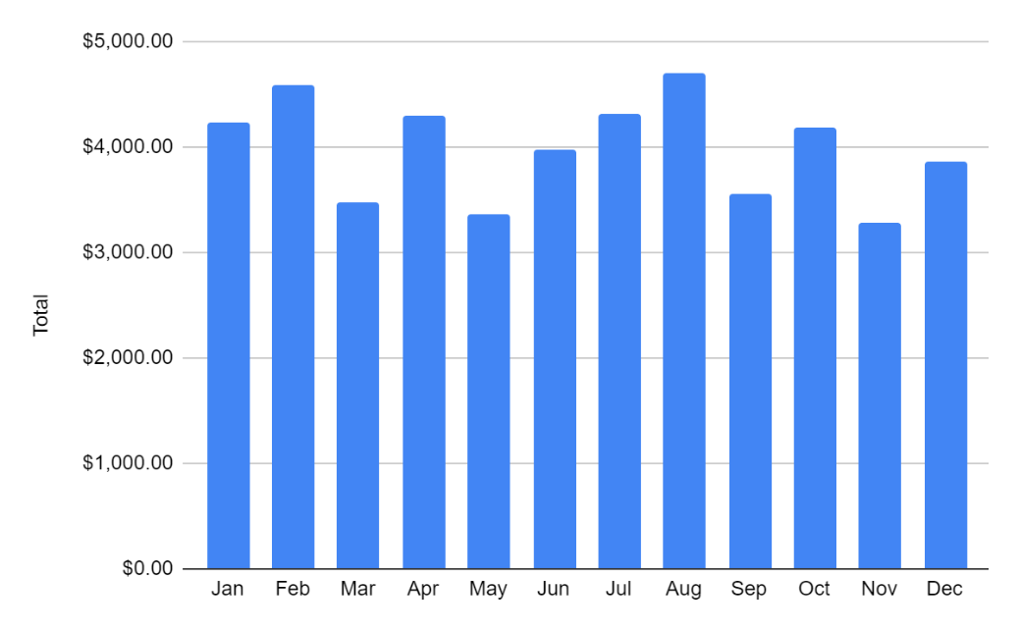

What info can you get from this bar graph?



Over the last few months Kate has spent more than her budgeted

amount for her cell phone bill. She decided to track her daily usage

to see if she should change plans. She went online to her cell phone

account and got the usage data at the right for the last three weeks.

Construct a multiple line graph comparing three weeks of phone use. The horizontal axis represents the days of the week and the vertical axis represents the minutes used.

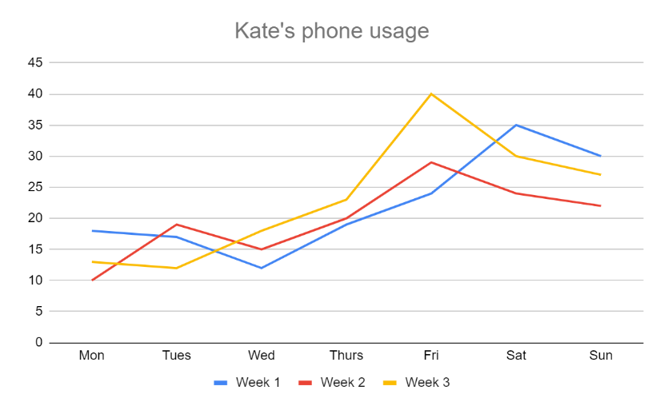

What do she learn from this chart. Stamp

Beth is a coffee lover.

In her budget, Beth has a section for coffee. She has budgeted $90 per month to spend on the coffee she buys in two different locations. At *GasMart*, a cup of coffee costs $1. At *The Perfect Coffee Company*, a cup of coffee costs $3. She tries to balance both through a month. Construct a budget line that shows the different combinations of the two types of coffee purchase options which allow her to stay within her budget. (use desmos)

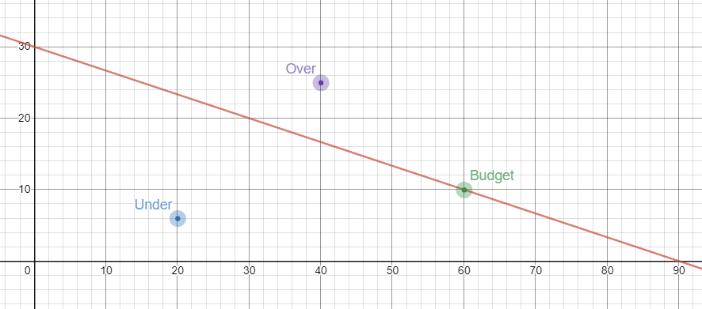

Let x be # of coffee at GasMart and y be # of coffee at The Perfect

We have x + 3y = 90

Show this graph for stamp and explain the meaning of the following points in the graph

A(20, 6)

B(60, 10)

C(40, 25)

Kate now decide to decrease her coffee budget by 20%. Identify at least three solutions using her new budget line. Stamp

A budget is more than just a matrix of numbers that charts your income and expenditures. It is a well-thought-out plan that is the result of careful examination of your financial goals and obligations. Budgets allow you to plan for future spending and saving. They give you control over your financial situation and allow you to make financially sound modifications to your lifestyle based upon comparing what was planned and what actually occurred.

Perhaps the most common financial goals that people make have to do with growing their savings

and reducing their debt. Once you have selected your goals, it is then important to take a close look at your current income and spending habits. This is a **cash flow analysis**. A cash flow analysis is not a budget. It has nothing to do with a financial plan nor does it incorporate goals. Rather, it is a detailing of how money comes in and how money goes out over a fixed period of time. By carefully monitoring your **cash flow**, you can get a better sense of the possibility of meeting your goals.

To create a monthly cash flow, you need data from the following categories

**Income** What can be your source of income?

**Fixed Expenses** These expenses are the same from month to month. For example, mortgage/rent, loan payments, insurance premiums, and so on. List your fixed monthly expenses?

**Variable Expenses** These expenses change each month. Your food and utility expenses are variable. List your monthly variable expenses?

Not all expense (bills) are monthly such as insurance, tuition, vacation, medical/dental, clothing.

List your non- monthly variable expenses?

Create your cash flow as of below. Use formula at total “cell”

Below are Trinh’s data, you may want to use your realistic number. Stamp

|  |  |  |  |  |
| --- | --- | --- | --- | --- |
| **Income** |  |  |  |  |
| Primary Employment | $5,600.00 |  |  |  |
| Secondary Employment | $500.00 |  |  |  |
| Other Income |  |  |  |  |
| **Total Income** | $6,100.00 |  |  |  |
| **Fixed Expenses** |  |  | **Non-Monthly Expenses (per year)** |  |
| Rent/Mortgage | $2,400.00 |  | Medical/Dental | $600.00 |
| Car Loan Payment | $200.00 |  | Auto Related | $700.00 |
| Education Loan Payment | $150.00 |  | Home Related | $500.00 |
| Personal Loan Payment | $80.00 |  | Life Insurance | $600.00 |
| Health Insurance Premium | $50.00 |  | Tuition | $3,000.00 |
| Life Insurance Premium |  |  | Vacation | $1,200.00 |
| Car Insurance Premium | $60.00 |  | Gifts | $400.00 |
| Homeowner's/renter's Insurance | $50.00 |  | Contributions | $400.00 |
| Cable TV |  |  | Repairs | $600.00 |
| **Total Fixed Expenses** | $2,990.00 |  | Taxes | $4,000.00 |
|  |  |  | Other |  |
| **Variable Expenses** |  |  | **Total Non-Montly Expenses (year)** | $12,000.00 |
| Groceries (Food) | $800.00 |  |  |  |
| Dining Out | $150.00 |  | **Total Non-Montly Expenses (month)** | $1,000.00 |
| Fuel (Car) | $160.00 |  |  |  |
| Cell phone | $120.00 |  | **Total Expenses** | $5,990.00 |
| Land Line Phone |  |  | **Monthly Cash Flow** | $110.00 |
| Electricity | $80.00 |  |  |  |
| Water | $30.00 |  |  |  |
| Sewer |  |  |  |  |
| Sanitation |  |  |  |  |
| Medical |  |  |  |  |
| Entertainment | $200.00 |  |  |  |
| Saving | $300.00 |  |  |  |
| Debt Reduction | $160.00 |  |  |  |
| Other |  |  |  |  |
| **Total Variable Expenses** | $2,000.00 |  |  |  |

Suppose that Trinh cash flow had been −$160 (instead of $110). What advice might you

give to him?

**Create, Use, and Modify a Budget**

Once the cash flow analysis has been completed, it is time to convert what you have learned into a working budget. A budget is a personalized plan. A budget that works for one person may not work for another. A budget can be a simple system. The **envelope accounting system** is a way to manage

your income with real dollars rather than with formulas and numbers in a matrix. Envelopes are set up to hold the allocated amount for weekly or monthly budget categories. Suppose you decide to budget $50 per week for dining out. This could include breakfast, lunch, dinner, or even snacks and coffee. Any time you pay for any item in this category, you take the money from the dining-out envelope. Once the money runs out, you have to wait until the next envelope allocation period comes around (usually on payday). If there is money remaining in the envelope at the end of a cycle, that money can be transferred to another envelope where funds are needed more. This system can work for people who have very few budgeting categories. College students might find this advantageous.

**Net Worth**

Budgeting and cash flow help you understand how to manage your money so that there is a financially responsible balance between the money coming in and the money going out.

In addition to this type of planning, it is also a good idea to ask yourself the question “Where do I stand financially today?” To do so, you need to calculate your net worth. **Net worth** is the difference between

your **assets** (what you own) and your **liabilities** (what you owe). The result can be a positive or a negative number.

You should calculate your net worth at regular intervals of perhaps once or twice a year, to determine if there have been changes in your financial status.

Liam Brown is single, in his mid-twenties, and owns a condo in a big city. He has calculated the following assets and liabilities.

|  |  |
| --- | --- |
| **Assets**  Current value of condo: $580,000  Current value of car (as listed in KBB): $17,000  Balance in checking account: $980  in all savings accounts: $22,500  Current balance in retirement account: $24,800  Current value of computer: $2,900  Current value of collector bass guitar: $6,700  Current value of stocks/bonds: $18,300 | **Liabilities**  Remaining balance owed on home mortgage: $380,000  Remaining balance owed on student loans: $51,000  Combined credit card debt: $1,600 |

Calculate Liam’s net worth. Last year at this time, he calculated his net worth as $205,780.

Compare both values. What do the changes mean?

**Assessment Target 18**

* **I can…** Prepare a budget

Mark works at two jobs. His primary job is a commission-paid job. Therefore, his monthly income from this job varies. His secondary job has a fixed monthly income. His quarterly dividend checks

and interest income have varied but not by a large amount. He used actual amounts from the previous year to set up this budget for the upcoming year.



Create the matrix budget then construct the pie chart and bar graph for the data. Stamp

What is the percentage of his secondary job?

What is his average monthly income? What months fell below the average?

A consumer budgets $480 per month for transportation. She has determined that the cost of a round-trip train ride is $4 and the cost of each round-trip car ride (factoring in gas, oil, etc.) is $3.

Write and graph a budget line equation for this situation.

Create 3 example that show the situation of under budget, on budget and over budget/

Suppose that the budgeted amount increases to $516. Identify at least 2 solutions using new budget line.

